Notes concerning the relationship of ‘our Munros’ to Sir Hector Munro and the Gordon Estate, from information assembled by Ardis Kamra:

“Here is a bio of Sir Hector Munro of Novar and our family written by my Aunt Chris [Christiana Munro Sneath Stewart]. I think I also have a handwritten account of Great Aunt Isabel's visit to Novar in Scotland” (See below Aunt Chris’s separate bio ‘Sir Hector Munro’.)
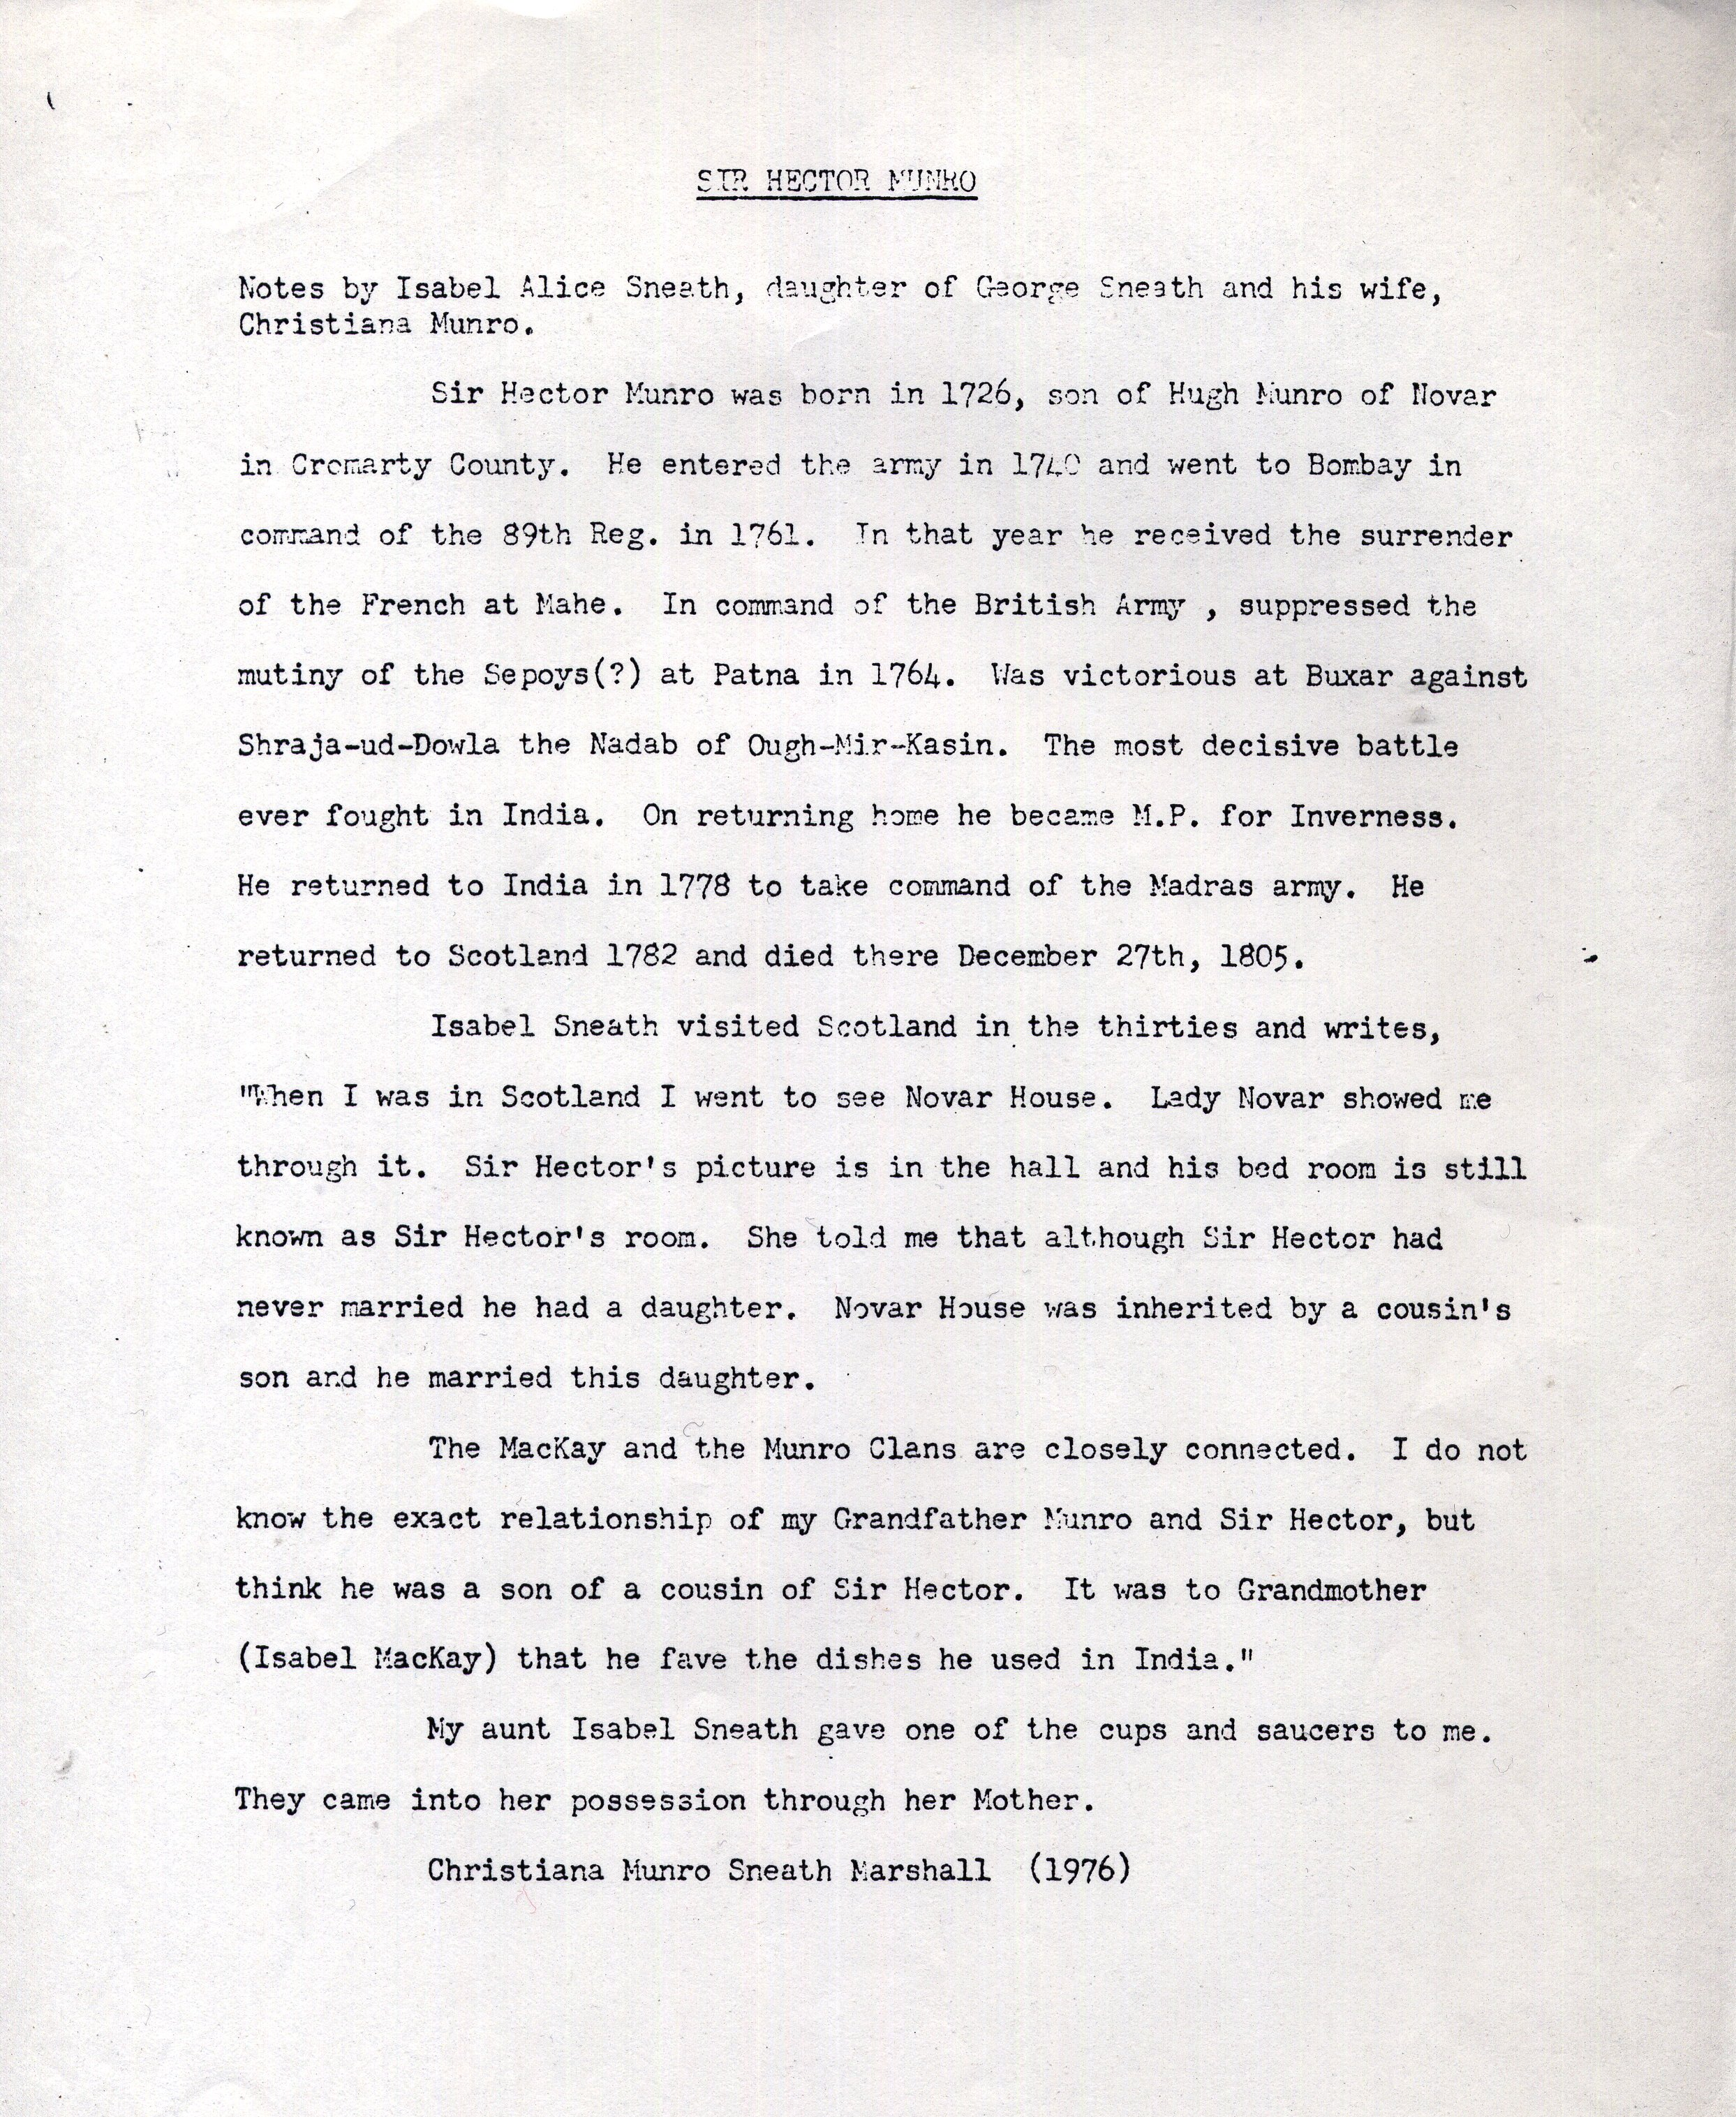

Further, from Ardis:

Novar Estate is near Evanton, Rosshire, overlooking Cromarty Firth. It covers 20,000 acres of hilly woodland and in addition to the main house, there are several other dwellings.

Hector Munro was the son of a general merchant who ran a shop on the riverfront of Inverness. He received his commission in the army because he had saved the life of the Duchess of Sutherland. She was going home in her carriage one evening but her coachman was drunk and lost control of the horse. Hector happened to be walking down the same road, assessed the situation, stopped the runaway horse and got the lady safely home. As a result, he became her protegé.

Through a series of deaths, including that of an Uncle in the succession to Novar, Hector's father inherited the Estate and the Title of Novar. Later in the 1770s or so Hector, as eldest son, inherited from his father. The house at that time was smaller but Hector spent a considerable fortune enlarging it and landscaping the property. The money came from the loot that he collected in the Battle of Buxar in the 1760s. (I might point our here that my Indian relatives are not at all happy that I might have even a remote connection to this man.)

The win at Buxar is attributed to a very clever pincer movement that Hector devised. I've read both the English and the Indian accounts.

The present inhabitants of Novar, Ronald Munro Ferguson and his wife are descendants of the daughter [her name was Jane or Jean] mentioned in Aunt Chris's account. But our John and Isabella were not descendants of this Jane. (Actually Jane and Jean are the same name used interchangeably for the same person.)

I have portraits of Jane, Isabella, her mother and of Hector but I don't think at this point they are relevant to our website.

________________

Discussion with Ardis concerning Isabella having met John while ‘walking on the beach’—wherein we were conjecturing who she may have been accompanying. I thought Isabella may have been a ‘lady’s maid; Ardis thinks differently:

“For Isabella to be a lady's maid just doesn't fit the facts. There would not have been any objection to John’s marrying a maid. From Christiana we have the story that Isabella was a cousin of Hector Munro and that she was born on the Gordon Estate in Inverness, got her middle name "Gordon" at the request of the Duchess of Gordon (who, from internet accounts, was quite wild lady) and that she went to Novar House for her lying-in with Christiana. A better explanation would be that she was out walking with the Duchess when she met John...not as a lady's maid but an attendant. A maid would not be permitted to talk to anyone while working.”

“The Novar story was so strong in the Sneath family that my grandmother's sister Isabel Sneath actually went there in the 1930s expecting to clarify the stories she heard from her mother [Christiana]. So could we make her an attendant or young friend rather than a maid?”

